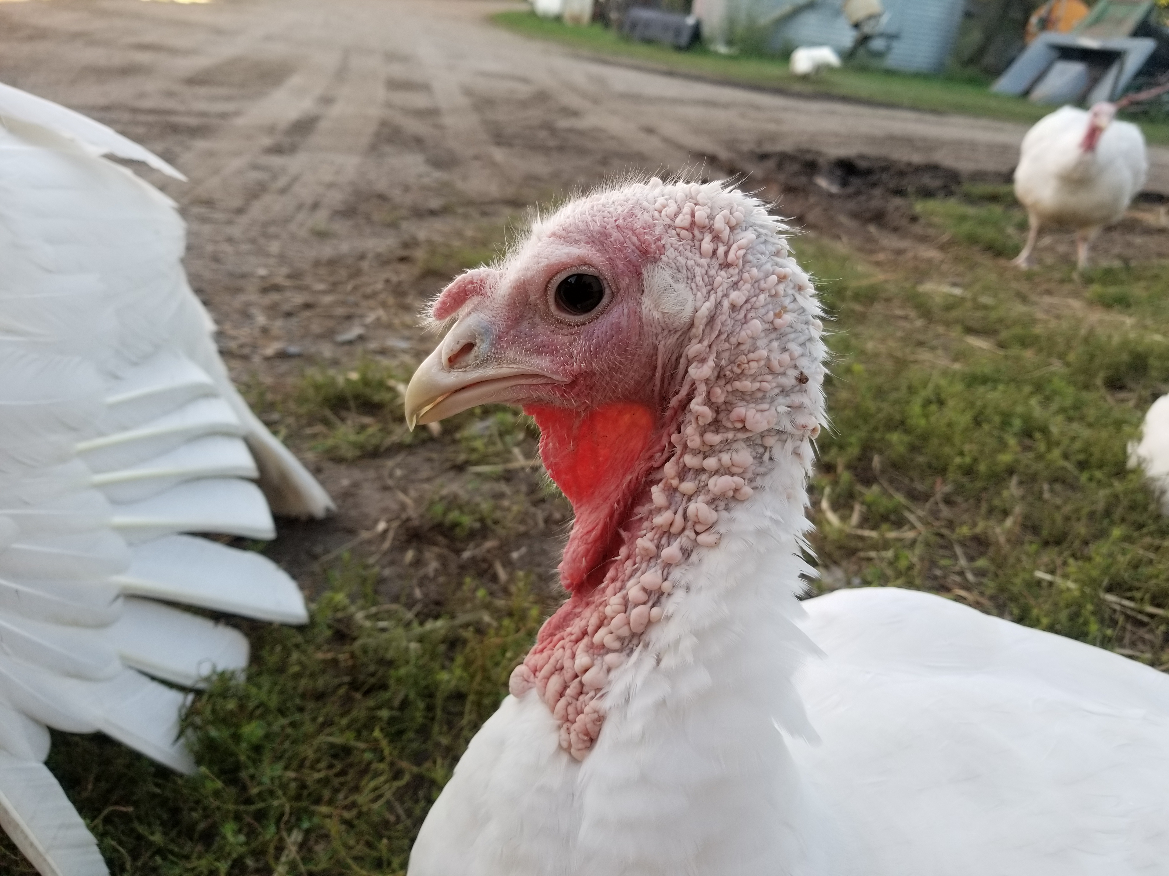
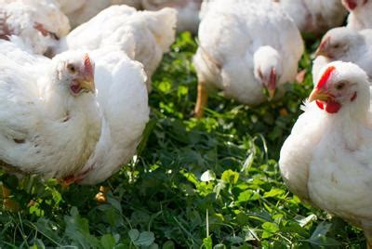
Poultry Order Form

Thank you for choosing to purchase locally-grown food from Little Elk Organic Farm! When you purchase poultry from us, you can expect meat from birds that have been
- NEVER treated with antibiotics or synthetic medicines
- free-range their whole life and pastured on grass since they were old enough
- fed Organic feed their whole lives
- lovingly cared for from day 1
All packaged, frozen, and brought back to the farm for you to pick up at your convenience.

Chickens:
Our chickens are purchased as day-old chicks raised in our warm brooder house until they are old enough to be moved outside to our home-made “chicken tractors,” where they will be moved to fresh pasture every day. Their diet will consist of fresh grass, broadleaves, weeds, and bugs, in addition to their organic feed and fresh water. We will raise two batches of chickens this summer: the first batch will be ready probably in July sometime, weighing in at around 7 to 8 pounds dressed. They must be picked up from our farm within two weeks of being processed unless you make prior arrangements with us.
The second batch of chickens will be ready by late August. You need to pick these up from our farm within two weeks as well, unless you also ordered a turkey or a goose and want to pick them all up closer to Thanksgiving, but you must make arrangements with us beforehand.
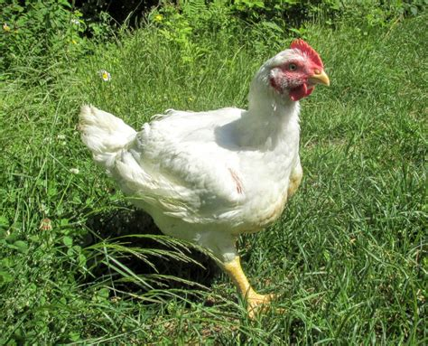
These may be smaller, depending on how fast they grow.
Price: $5 per pound, dressed weight

Turkeys:
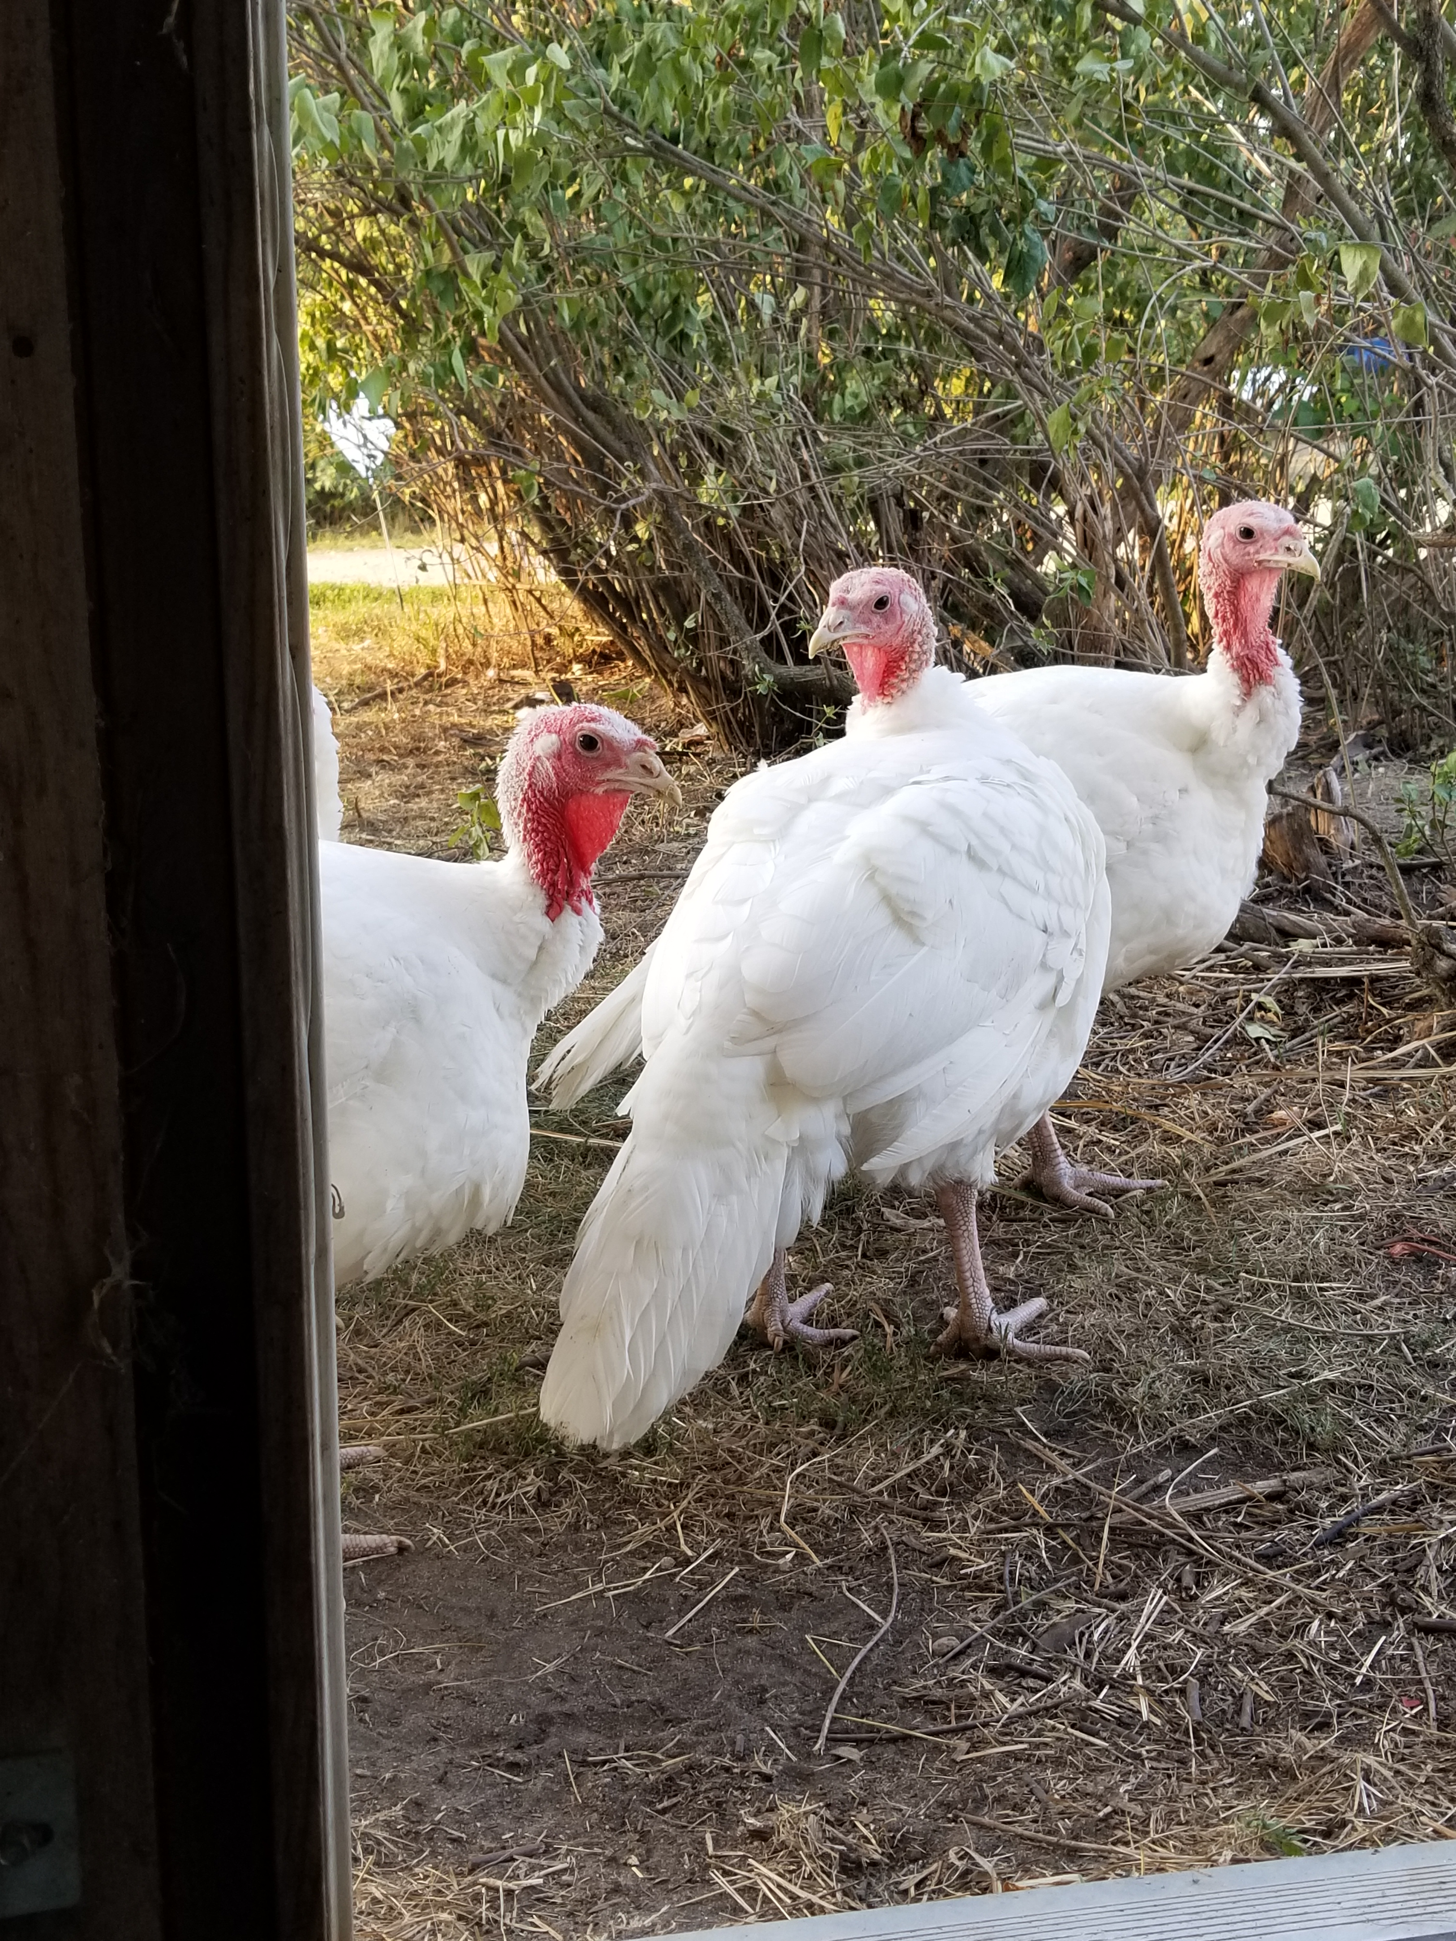
We purchase our baby turkeys (poults) as day-olds, just like the chickens and they are raised similarly in a brooder house until they can be moved to their own “turkey-tractors.” When they get too big for the tractors, they will be moved to a more open pen where they will also get moved every day to fresh pasture. We’re hoping to have the dressed turkeys weighing in at about 18 pounds or so. Final weight will depend on a number of factors. The turkeys will be processed in late August and may be picked up immediately afterward, or we can store them in our freezer until closer to Thanksgiving to save space in your freezer. You must make arrangements with us so we know what you are planning.
Price: $6 per pound, dressed weight

Geese:
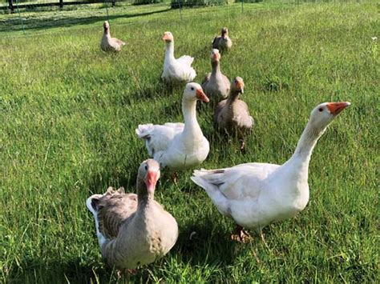
We have never raised geese on our farm before, so this is a new experiment for us. As with the chickens and turkeys, we will purchase day-old goslings and start them similarly to the other birds. Geese are very good grazers and, when they are old enough, we hope to utilize them to weed our orchard area and other hard-to-mow places on the farm, protecting them with electric netting fence. We really don’t know how big they will be at butchering, so it will be a surprise! A note: The processor that will handle the turkeys and chickens will NOT butcher geese, so we will have to butcher them ourselves on the farm. One of the challenges of geese is the abundance of pinfeathers, and if on processing day there’s too many pinfeathers to get the skin clean, we will remove the skin of the birds, which may change how you decide to cook them.
Price: $7 per pound, dressed weight

Necks, livers, gizzards, and hearts will be available in 1/2-pound packages when you pick up the rest of your meat, though you are encouraged to speak for them ahead of time as they are sold on a first-come, first-served basis.
Price: $3 per pound

Your meat can be picked up at our farm. You will be notified when the baby chicks come, when they are sent to the butcher, and when they are ready for you to pick them up at the farm. If you fail to make arrangements with us to pick up your meat and we can’t get ahold of you, two weeks after processing you will forfeit your right to that meat, as well as your deposit, and it will be sold to someone else.
If unforeseen circumstances occur on our farm and for whatever reason we cannot supply some or any of the requested meat, your down payment will be refunded to you or applied to any outstanding balance of yours.
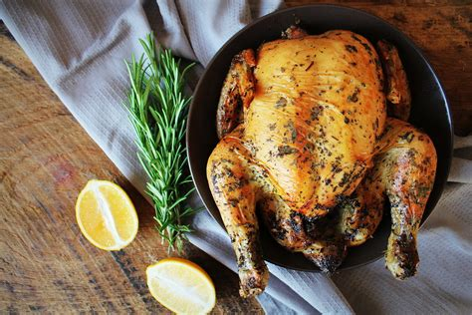
We require a deposit on each bird that you order, see form below. The final price will be calculated when you pick up the meat, based on the exact weight of each bird. Please fill out this order form and mail it to us with a check for your deposit by no later than March 15, 2022. Send check to:
Michael Dalquist 207 w. 6th St Randall, MN 56475

Product | When ready | Dressed wt | # you want | Deposit | Deposit total $
Whole chicken | July | 8 pounds |  | $5 each | $
Whole chicken | September | 8 pounds |  | $5 each | $
Whole Turkey | September | 18 pounds |  | $20 each | $
Whole Goose | September | 8 pounds |  | $20 each | $
 |  |  |  | Total | $

Necks, gizzards, hearts, livers? How many packages of each (½ #)?

Please circle when you intend to pick up your meat: July September October November

Print Name: Date:

Signature:

Please indicate your preferred method of communication with a checkmark and write your contact information

- Phone:

- Mailing address:

- Email address:

